LET IV Study Guide 2017

The Department of Defense

1. (U1C2L1:Q1) Review the chart and select the option (A-D) that correctly completes the Chain of Command flow chart.
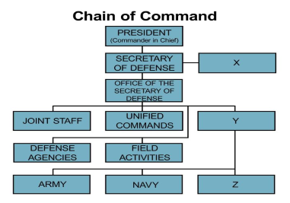

A) X = Assistant Secretary of Defense
Y = Military Departments
Z = Marine Corps
B) X = Deputy Secretary of Defense
Y = Military Departments
Z = Air Force
C) X = Under Secretary of Defense
Y = Army Chief of Staff
Z = Air Force
D) X = Chairman of the Joint Chiefs of Staff
Y = Under Secretary of Defense
Z = Special Operations

2. (U1C2L1:Q3) Analyze the charts and decide which one best represents your chain of command as a JROTC Cadet.

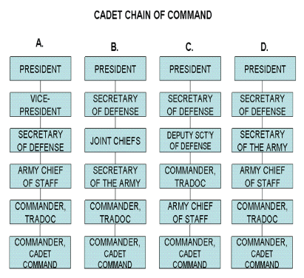

A) A
B) B
C) C
D) D

3. (U1C2L1:Q4) You are the Commander-in-Chief (CINC) of our Armed Forces in one of the nine geographical areas of the world. You have identified an enemy threat, developed a plan to combat that threat, and organized your forces to execute your plan. Even though you haven't received permission to attack from the Department of Defense, your intelligence (which is about 97% sure) indicates that the best time to execute your plan is now.

What prevents you from proceeding with your plan?
A) Nothing. You are the CINC of all of our Armed Forces in this area of the world, and you should order your forces to attack.
B) Nothing. You have a good plan, good forces, and intelligence has shown that your plan will probably be successful.
C) You have not received permission from the responsible civilian official who has the authority to make that decision.
D) The Chairman of the JCS hasn't commanded you to execute your plan.

4. (U1C2L1:G1) What executive department is responsible for the nation's defense force?
A) The Department of Defense
B) The Department of State
C) The Department of Homeland Security
D) The Department of the Treasury

5. (U1C2L1:G2) What is the mission of the Department of Defense?
A) Strategic and tactical division of combatant forces.
B) To provide the military forces needed to deter war and protect the security of the United States.
C) The operation of combatant forces under unified command.
D) Research and development on effective military tactics and machinery.

6. (U1C2L1:G3) What is the role of the Secretary of Defense and how is he or she appointed?

A) The Secretary is the principal defense policy advisor to the President. He or she is appointed by the President but subject to Senate approval.
B) The principal defense policy advisor to the President is appointed by popular vote.
C) The principal defense policy advisor to the Senate and Congress is appointed by popular vote.
D) The principal economic advisor to the President is appointed by the President and confirmed by the Senate.

7. (U1C2L1:G4) Name the order of the presidential succession through the Secretary of Defense.

A) Speaker of the House; Vice President; President Pro Tempore of the Senate; Secretary of State; Secretary of Treasurer; Secretary of Defense
B) Speaker of the House; Vice President; President Pro Tempore of the Senate; Secretary of State; Secretary of Commerce; Secretary of Defense
C) Vice President; Speaker of the House; President Pro Tempore of the Senate; Secretary of State; Secretary of Treasury; Secretary of Defense
D) Speaker of the House; Vice President; President Pro Tempore of the Senate; Secretary of State; Chairman of the Joint Chiefs of Staff; Secretary of Defense

8. (U1C2L1:G5) Who constitutes the collective body of the Joint Chiefs of Staff?

A) The President; Vice-Chairman; Chief of Staff of the Army; Chief of Naval Operations; Chief of Staff of the Air Force; and the Commandant of the Marine Corps.
B) The President; Vice-Chairman; Chief of Staff of the Army; Chief of Naval Operations; Chief of Staff of the Air Force; and the Secretary of Defense.
C) The President; Vice-Chairman; Chief of Staff of the Army; Chief of Naval Operations; Chief of Staff of the Air Force; and the Secretary of State.
D) The Chairman; Vice-Chairman; Chief of Staff of the Army; Chief of Naval Operations; Chief of Staff of the Air Force; and the Commandant of the Marine Corps.

9. (U1C2L1:G7) What are the main responsibilities of the Joint Chiefs of Staff?

A) To keep peace in the U.S. and in U.S. territories.
B) To identify other countries that could benefit from democratic self-rule.
C) Strategic and tactical direction of combatant forces; operation of combatant forces under unified commands; integration of combatant forces; research and development.
D) None of the above.
10. (U1C2L1:G8) In military terminology, what is a "theater"?

A) A graphic organizer or table top map for charting troop movements.
B) A panoramic view of the battlefield as seen from an aircraft or satellite picture.
C) A large geographic area (including its land, sea, and air) in which active military operations are coordinated and conducted.
D) A designated area for performance to entertain troops.

11. (U1C2L1:G9) Large scale or global planning and conduct of military strategy, movements, and/or operations essential to the effective conduct of war is called ____________.

A) Organizational planning
B) Strategic planning
C) Theatre planning
D) Special operations

12. (U1C2L1:G10) T or F: The Joint Chiefs of Staff have the executive authority to command combatant forces.

A) True
B) False

13. (U1C2L1:G11) In the U.S., who has the power to raise and support armies and to declare war?

A) Secretary of State
B) President
C) Senate
D) Congress

14. (U1C2L1:G14) The executive department responsible for the nation's defense force is ______________.

A) Department of the Interior
B) Department of State
C) Department of Defense
D) Department of Homeland Security

15. (U1C2L1:G15) T or F: The appointment of the Secretary of Defense is solely at the discretion of the President.

A) True
B) False

16. (U1C2L1:G16) The Vice President is second in succession to the President. Define "succession."

A) The order of persons next in line for an office or rank that is held by another.
B) The person most likely to be voted into office if the President dies.
C) The person most likely to be successful in a job.
D) None of the above.

17. (U1C2L1:G17) What entity in the U.S. has the power and authority to raise and support armies and declare war?

A) President
B) Congress
C) Senate
D) Secretary of Defense

18. (U1C2L1:G18) The Department of _________ is responsible for the nation's defense force.

A) State
B) Homeland Security
C) Defense
D) National Guard

19. (U1C2L1:G19) Whose mission is it to provide the military forces needed to deter war and protect the security of the United States?

A) The Department of Homeland Security
B) The various state National Guards
C) The Federal Bureau of Investigation
D) The Department of Defense

20. (U1C2L1:G20) Who is the principal defense policy advisor to the President, and how is the advisor appointed?

A) The National Security Advisor is appointed by the President.
B) The Secretary of Defense is appointed by the President but subject to Senate approval.
C) The chairman of the Joint Chiefs of Staff is promoted to the position.
D) The Secretary of the Department of Homeland Security is approved by the Senate.

21. (U1C2L1:G21) What U.S. agency is headquartered in the Pentagon?

A) The U.S. Department of State
B) The Department of Defense
C) The Department of Homeland Security
D) The U.S. Army

22. (U1C2L1:G22) A large geographic area (including land, sea, and air) in which active military operations are coordinated and conducted is called a ________________.

A) Theater
B) Combat zone
C) Area of operations or AO
D) AAMO, short for area of active military operations

23. (U1C2L1:G23) What is "strategic planning" in the military?

A) A long range plan for deployment of a military unit.
B) Large scale or global planning and conduct of military strategy, movements, and/or operations essential to the effective conduct of war.
C) A plan designed to display strength and thereby deter war.
D) Air Force plan made by the U.S. Air Force Strategic Lift Command.

24. (U1C2L1:G24) Explain the chain-of-command used to command combatant forces during times of war.

A) The chain of command runs from the President to the Combatant Forces Commander.
B) The President directs the chairman of the Joint Chiefs who directs the field commander.
C) The chain of command runs from the Secretary of Defense to the Joint Chiefs to the field commanders.
D) The chain of command runs from the president, through the Secretary of Defense, to the military generals of the Unified Combatant Commands.

25. (U1C2L1:G25) T or F: The Joint Chiefs of Staff have the authority to command combatant forces.
A) True
B) False

26. (U1C2L1:G26) In the U.S., the __________ has the power to raise and support armies and to declare war.
A) U.S. House of Representatives
B) President
C) Secretary of Defense
D) Congress

27. (U1C2L1:F1) The Army JROTC is part of which government agency?

A) Department of Justice
B) Department of Finance
C) Department of Defense
D) Department of Education

28. (U1C2L1:V1) Operational Commands ` 29. (U1C2L1:V2) Specified
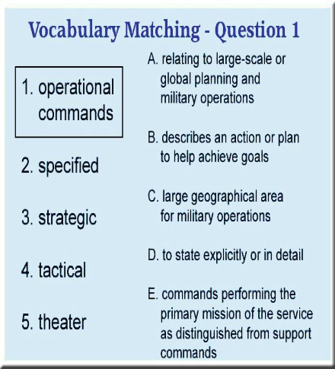
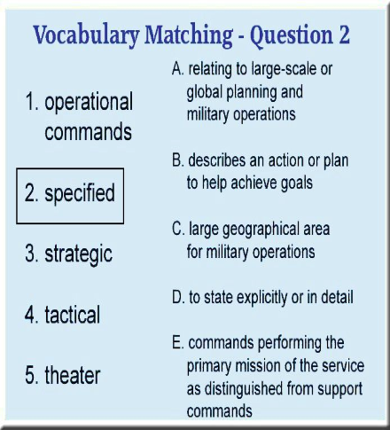

A) A)
B) B)
C) C)
D) D)
E) E)

30. (U1C2L1:V3) Strategic 31. (U1C2L1:V4) Tactical
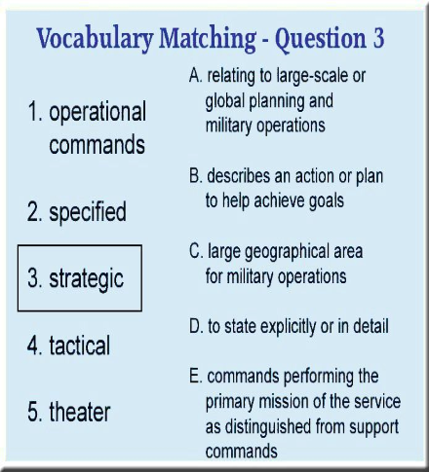
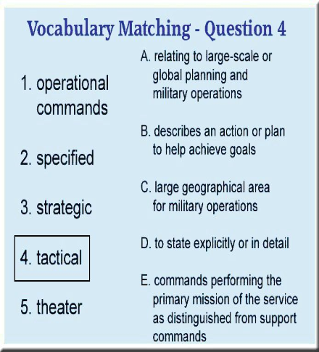
A) A)
B) B)
C) C)
D) D)
E) E)

32. (U1C2L1:V5) Theater

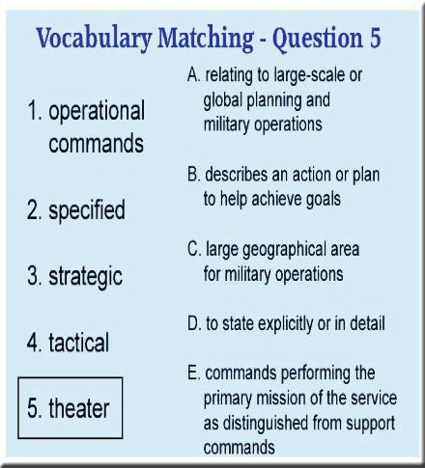

A)
B)
C)
D)
E)

The Active Army

33. (U1C2L2:Q1) Another Cadet made this poster of the Army Branches. What would you tell her to make the chart accurate?

Army Branches:

Combat Arms (CA):
Infantry
Armor
Field Artillery (FA)
Air Defense Artillery (ADA)
MP Corps
Corps of Engineers
A) Remove "Corps of Engineers" from the CA and CSS branches
Combat Support (CS): B) Switch "MP Corps" in CA with "Aviation" in CS
Corps of Engineers C) Switch "Air Defense Artillery" in CA with Signal Corps" in CS
Chemical Corps D) Remove "Signal Corps, Chemical Corps, and MP Corps" from the CSS branch
Signal Corps
Aviation
Military Intelligence

Combat Service Support (CSS):
Adjutant General
Corps of Engineers
Finance Corps
Quartermaster Corps
Signal, Chemical, and MP Corps
Ordnance Corps
Transportation Corps
Army Medical Department
Chaplains

34. (U1C2L2:Q2) The Active Army contributes in peacetime to the nation's welfare through domestic involvement.

Which of the following actions does NOT represent a domestic Army mission during peacetime?

A) An Army unit provides meals and clean water to victims of a hurricane.
B) An Engineer unit builds sandbag walls to stop floodwaters from reaching homes in a community.
C) A Military Police unit assists a local police force maintain order after a peaceful protest turned into a riot.
D) A Finance unit provides personnel to run a bank during a strike of bank tellers.

35. (U1C2L2:Q3) The ___________ authorizes the strength of the Active (or Regular) Army.

A) Department of Defense
B) Congress
C) President of the United States
D) Office of Budget Management

36. (U1C2L2:Q4) Our active Army is organized in accordance with the U. S. Constitution, the National Security Act of 1947 and it's Amendments of 1949, and the Army Organization Act of 1950.

If a friend of yours wants to research the Office of the Secretary of Defense, which act would you tell him to research?

A) An amendment to the U. S. Constitution
B) The National Security Act of 1947
C) The Amendments to the National Security Act of 1949
D) The Army Organization Act of 1950.

37. (U1C2L2:G1) Name the three components that make up the U.S. Army.

A) Active Army, the reserve components, and Department of Defense workers
B) Active Army, the reserve components, and the Department of the Army civilian work force
C) Active Army, Air National Guard, and the reserve components
D) Officers, Enlisted personnel, and intelligence operatives

38. (U1C2L2:G2) Name the two components of the reserves.

A) The Army National Guard and the U.S. Army Reserves
B) Officers and Enlisted Personnel
C) Retired and Active Duty
D) The Air National Guard and the Army Reserves

39. (U1C2L2:G3) What is the purpose of retaining reserve components of the U.S. Army?

A) To employ former JROTC Cadets as qualified personnel to be available for active duty in time of war, national emergency, or at other times as directed by national security requirements.
B) To protect the U.S. when the regular Army is deployed abroad in time of war, national emergency, or at other times as directed by national security requirements.
C) To provide trained units and qualified personnel to be available for active duty in time of war, national emergency, or at other times as directed by a governor of a state.
D) To provide trained units and qualified personnel to be available for active duty in time of war, national emergency, or at other times as directed by national security requirements.

40. (U1C2L2:G4) T or F: The Army contributes in peacetime to the nation's welfare through domestic involvement, but the scope of that involvement is limited by federal law.

A) True
B) False

41. (U1C2L2:G5) In military jargon, what does "CONUS" stand for?
A) Continental United States
B) Contained on U.S. soil
C) Coordinated through the U.S.
D) Continuous United States
42. (U1C2L2:G6) The Infantry, Armor, Field Artillery, Air Defense Artillery, Aviation, and the Corps of Engineers are the six branches of ______________ in the Army.

A) Management
B) Intelligence
C) Reserves
D) Combat Arms

43. (U1C2L2:G7) What does "FORSCOM" stand for in military jargon, and where is it located?

A) First Order Response on Command, located in Fort Irwin, California
B) Force Satellite Communications, located in Utah
C) Forces Command, located at Fort Bragg, North Carolina
D) Commandant of Forces at Fort Collins, Colorado

44. (U1C2L2:G8) What does "TRADOC" stand for in Army jargon, and where is it located?

A) Tradition of Command, located in Fort Leavenworth, Kansas.
B) Training and Delivery on Command, located in Fort Carson, Colorado.
C) Training and Doctrine Command, located in Fort Eustis, Virginia.
D) Training, Attitude, and Decision Command, located in Fort Wayne, Indiana.

45. (U1C2L2:G9) What Army command controls all the combat and support units at installations throughout the U.S.?

A) FORSCOM, or Forces Command
B) USCOM, or U.S. Command
C) TRADOC, or Training and Doctrine Command
D) SUPCOM, or Support and Combat Command

46. (U1C2L2:G10) Define "avionics."

A) A nickname for aviators, a "flyboy."
B) The term for a female aviator.
C) A shorthand term for aviation electronics.
D) Nicknames that aviators give one another for use in radio transmissions while they are aloft.

47. (U1C2L2:G11) Which of the following is NOT one of the six combat arms brances in the army?
A) Field Artillery
B) Aviation
C) Infantry
D) Military Police

48. (U1C2L2:G13) The Special Forces and Civil Affair branches of the Army are non-accession branches. Define "non-accession."
A) The policy or practice of not accepting personnel directly from non-traditional sources.
B) Soldiers in these branches are promoted in unusual ways, such as battlefield commissions.
C) The policy or practice of not accepting personnel directly from traditional officer or enlisted entrance sources.
D) The policy or practice of accepting personnel directly from traditional officer or enlisted entrance sources.

49. (U1C2L2:G14) What branch of the Army accomplishes missions of unconventional warfare, foreign internal defense, direct action, strategic reconnaissance, and counterterrorism?

A) Navy Seals
B) Special Forces
C) Aviation
D) Military Police Investigators

50. (U1C2L2:G15) What is the oldest branch of the U.S. Armed Forces?

A) U.S. Navy
B) U.S. Army
C) U.S. Marines
D) U.S. Air Force
51. (U1C2L2:G16) The three components that make up the U.S. Army are the Active Army, the Army Reserves and ___________.

A) Department of the Army Civilian Workforce
B) Army National Guard
C) Army Ready Reserve
D) Inactive Army

52. (U1C2L2:G17) Forces Command, located in Fort Bragg, North Carolina, is also called ______________.

A) FORSCOM
B) Troop command
C) The key personal command of the U.S. Army
D) F-troops command

53. (U1C2L2:G18) The Army command that controls all the combat and support units at installations throughout the U.S. is called ______________.

A) FORSCOM
B) Joint Army Command
C) TRADOC
D) Unified Troop Command or UTC

54. (U1C2L2:G19) The U.S. Army ROTC Cadet Command is a subordinate of what major command?

A) TRADOC
B) FORSCOM
C) Fort Monroe, Virginia

D) The United States Military Academy

55. (U1C2L2:G20) In the military, what does TRADOC stand for?

A) Training and Doctrine Command
B) Training of Doctors
C) Train and Distribution of Cohorts
D) Train Real Army Defense Command

56. (U1C2L2:G21) What are the six branches of Combat Arms in the Army?

A) Infantry, Armor, Field Artillery, Air Defense Artillery, Aviation, and Corps of Engineers
B) Military Police, Infantry, Aviation, Field Artillery, Armor, and JAG
C) Armor, Infantry, JAG, Aviation, Military Police, and Special Operations
D) Special Operations, Infantry, Armor, Field Artillery, Air Defense Artillery, and Aviation

57. (U1C2L2:G22) The branches of the U.S. Army that are directly involved in the conduct of actual fighting during times of war are called _______________.

A) Infantry
B) Combat Arms
C) Combat Support Arms
D) JAG

58. (U1C2L2:G23) Name the two branches of the Army that are non-accession branches and do not accept personnel in a traditional manner.

A) Special Forces and Civilian Affairs
B) Staff Judge Advocate
C) Medical Corps
D) Aviation Branch

59. (U1C2L2:G24) The ______________ branch of the Army uses unconventional warfare, foreign internal defense, strategic reconnaissance and counterterrorism to accomplish its mission.

A) Navy Seals
B) Special Weapon and Ammunition Teams (SWAT)
C) Special Forces
D) JAG

60. (U1C2L2:F1) The Army defends American interests by:

A) defending the U.S. Constitution against foreign enemies
B) defending the U.S. Constitution against foreign and domestic enemies
C) conducting land-only defenses on the battlefield
D) conducting defense operations at sea

61. (U1C2L2:G12) What branches of the U.S. Army are usually directly involved in the conduct of actual fighting?

A) Combat Service Support branches
B) Military Police
C) Judge Advocate General (JAG)
D) Combat Arms

62. (U1C2L2:V1) Choose the word that best completes the sentence below.

The Special Forces and Civil Affairs are __________ branches of the military.

A) nonaccession
B) doctrine
C) unconventional
D) counterintelligence

63. (U1C2L2:V2) Choose the word that best completes the sentence below.

Military Intelligence uses _________ to prevent sabotage and to gather military information.

A) nonaccession
B) doctrine
C) unconventional
D) counterintelligence

64. (U1C2L2:V3) Choose the word that best completes the sentence below.

TRADOC is responsible for developing Army ______ and training.

A) nonaccession
B) doctrine
C) unconventional
D) counterintelligence

65. (U1C2L2:V4) Choose the word that best completes the sentence below.

Special Forces accomplish missions of _____ warfare, foreign internal defense, direct action, strategic reconnaissance, and counterterrorism.

A) nonaccession
B) doctrine
C) unconventional
D) counterintelligence

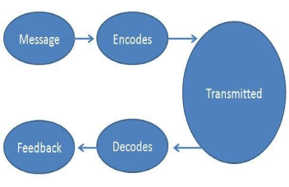
Communication

66. (U2C6L4:F1) What process does this graphic represent?

A) Transference Process
B) Intelligence Process
C) Emotional Process
D) Communication Process

67. (U2C6L4:Q1) In World War II, our armed forces used Native Americans from the Navajo tribe to send Top Secret messages over the radio in their native language. The Axis Powers intelligence forces did not have anyone who spoke the language of the Navajo, so they could not determine what information was contained in the messages. What parts of the communication process were these Native Americans?
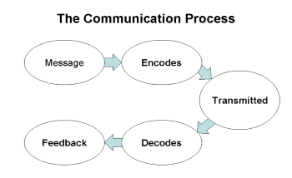

A) Encodes and Decodes
B) Encodes and Transmit
C) Message and Feedback
D) Decodes and Feedback

68. (U2C6L4:Q2) When a radio message ends with, "Wilco, Out" it means "I have received your message and will comply; this is the end of the message and you don't have to reply."

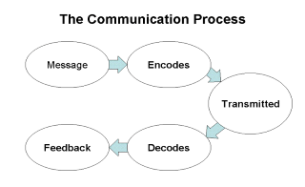
What part of the communication process is "Wilco, Out"

A) Message
B) Encode
C) Decode
D) Feedback

69. (U2C6L4:Q3) George was standing in line at the Toy Store after buying his niece a birthday present. A real pushy person cut in to the front of the line. Though he could feel his anger growing, George took a deep breath; then he told himself that he wasn't in a hurry, and if an adult cuts in line, then that person probably has some serious maturity issues. He didn't say anything.

Which emotion management skill is George applying?

A) Empathy
B) Self-awareness
C) Self-motivation
D) Self-regulation
70. (U2C6L4:Q4) Providing effective feedback, both positive and constructive, is a key part of the communication process.

Which of the following is not an effective method of providing effective feedback?

A) Ask permission: "May I talk to you about something I observed in your performance?"
B) Focus on specific behaviors: "You seemed to be anxious at the start of the exam."
C) Get feedback from more than one source to validate the feedback.
D) Provide feedback immediate after a message has been sent; an action has been completed; or when feedback is primarily negative.

71. (U2C6L4:G1) T or F: Feedback to subordinates is most effective when it is immediate.

A) True
B) False

72. (U2C6L4:G2) ___________ is defined as the transference of understanding of a meaning.
A) Listening
B) Communication
C) Talking
D) Debate

73. (U2C6L4:G3) Communication has two parts: ____________ and understanding.
A) Sending
B) Transference
C) Comprehension
D) Dissention

74. (U2C6L4:G4) What do we mean when we say a person has a high degree of "emotional intelligence?"

A) That person is academically very smart.
B) That person is highly driven by his or her emotions.
C) A person who suffers from manic depression.
D) A person aware that emotions are part of his or her reactions.

75. (U2C6L4:G5) Name the five competencies for managing emotions.

A) Self-awareness, self-regulation, self-motivation, empathy and effective relationships
B) Self-enlightenment, self-discipline, self-esteem, empathy, and effective relationships
C) Self-awareness, self-regulation, self-motivation, sympathy, and effective communication skills
D) None of the above

76. (U2C6L4:G6) What is self-awareness?
A) An awareness of one's body type.
B) An awareness of one's limitations.
C) An awareness of one's own emotions and where they are coming from.
D) An awareness of how others perceive you and the ability to change to match their perceptions.

77. (U2C6L4:G7) What is self regulation?

A) The ability to control one's emotions effectively rather than ignoring them or pushing them aside.
B) The ability of the body to maintain a constant temperature.
C) The ability to control one's intellect for effective learning.
D) The ability to control one's breathing to induce a state of relaxation or meditation.

78. (U2C6L4:G8) ___________ means being energetic and ambitious and able to make plans and get things done without being directed by others.

A) Self-motivation
B) Motivation
C) Self-esteem
D) Driven
79. (U2C6L4:G9) ___________ is the ability to experience the feelings of others and to share your feelings with others to improve the communication process.

A) Empathy
B) Sympathy
C) Understanding
D) Telepathy

80. (U2C6L4:G10) Name the four levels of communication.

A) Direct, indirect, subliminal, overt
B) Superficial, fact, thought, feeling
C) Intuitive, sub-conscious, non-verbal, verbal
D) Fact, intuition, feeling, rational

81. (U2C6L4:G11) T or F: Feedback is most effective when it is immediate.

A) True
B) False

82. (U2C6L4:G12) Name three characteristics of informative feedback.

A) Is limited, includes specific behaviors, and provides suggestions.
B) Describes all incorrect behaviors, lists many behaviors, and allows the subject to make a choice of which behavior to address.
C) Is limited, includes specific behaviors, and demands specific actions.
D) Describes all incorrect behaviors, ilsts many behaviors, and demands specific actions.

83. (U2C6L4:G13) What is the final closing point to the feedback process?

A) Write up an after-action report to document your feedback.
B) Checking the reviewer's perceptions about your feedback.
C) Check back after the receiver has finished the task to see that the receiver incorporated your feedback.
D) There is no closing point; all feedback is ongoing.

84. (U2C6L4:V1) Choose the term that best matches the definition: ("Sharing of information.")

A) transference
B) communication
C) decodes
D) emotional intelligence

85. (U2C6L4:V2) Choose the word that best matches the definition: ("The act of moving from one place to another.")
A) communication
B) transference
C) encodes
D) feedback

86. (U2C6L4:V3) Choose the word that best matches the definition below.

"A communication transmitted between persons by written or spoken word, signals, and so on."
A) decodes
B) feedback
C) message
D) transference

87. (U2C6L4:V4) Choose the word that best matches the definition: ("Converts")

A) decodes
B) transmitted
C) encodes
D) message
88. (U2C6L4:V5) Choose the term that best matches the definition: ("Sent from one person to another.")

A) communication
B) emotional intelligence
C) encodes
D) transmitted

89. (U2C6L4:V6) Choose the word that best matches the definition: ("Translates")

A) encodes
B) transmitted
C) transference
D) decodes

90. (U2C6L4:V7) Choose the term that best matches the definition: ("Verifying that a message was received in the manner it was intended.")

A) feedback
B) emotional intelligence
C) message
D) transmitted

91. (U2C6L4:V8) Choose the term that best matches the definition below.

"The ability for one to monitor their emotions and use information about those emotions to guide one's thinking and actions."

A) feedback
B) emotional intelligence
C) communication
D) message

Motivation

92. (U2C6L5:F1) Of these choices, which motivates you to do something the most?

A) To satisfy your own needs
B) The opportunity to win a reward
C) A friend or group's desire
D) A worthy cause

93. (U2C6L5:Q1) Read carefully the following paragraph and select the option (A-D) that indicates which Principle of Motivation is described.

Sergeant Jones knew that his team leaders would find their tasks to be extremely difficult. However, he also knew that they trusted him to help them develop their leadership and management skills. He wouldn't do the tasks for them, but he would be there to provide hints and mentor them when necessary, and he would always do his best to communicate his belief in them.

A) Have subordinates participate in the planning of upcoming events.
B) Use positive peer pressure to work for you, the leader, and the unit.
C) Give subordinates tough problems, and challenge them to wrestle with them.
D) Set the example in all things.

94. (U2C6L5:Q2) Privates Rawlings and Rice always seem to be the reasons for their squad not completing its missions. The other squad members have tried several times to get them to perform their best, but they just don't seem interested. Their squad leader has tried the "carrot" and other positive approaches to motivate them, but now feels she has to use the "stick" in the form of counseling.

Prior to the next squad task, what should she do?

A) Threaten them with negative consequences if they don't perform as they should.
B) Be certain that the task, mission, and standard are clearly communicated.
C) Remind the entire squad that rewards are earned.
D) Talk to the other squad members about using positive peer pressure.
95. (U2C6L5:Q3) A Cadet in your squad, Private Adams, got a medal for completing a task. You had a harder task, but you didn't get one. You asked your squad leader, "Why not?" He told you: "Even though his performance is usually not good, I gave Private Adams a medal because he did a great job on this task. I know it was an easier task that you did, but you already have a bunch of medals, and he didn't have any. I did tell you "Great job!" when you were finished, and I meant that. However, Private Adams needed something special to make him feel like he is an important part of this squad and to give him some hope for the future."

Did your squad leader do the right thing? Why or why not? Select the answer (A-D) that is most correct.

A) No. Private Adams prior performance was not good, so he should not have given him a medal.
B) No. He should also have given a medal to both of them.
C) Yes. He was trying to improve Private Adams' performance, and by rewarding him with a medal for doing a great job, he also is showing Private Adams the benefits of good performance.
D) Yes. Everyone deserves medals for doing a good job.

96. (U2C6L5:G2) T or F: Rewarding team members who support unit tasks by giving them ribbons, medals, or certificates is effective because doing so satisfies social needs and serves as a motivator.

A) True
B) False

97. (U2C6L5:G3) If a leader must counsel subordinates for negative behaviors, when and where should that counseling take place?

A) Counseling should take place instantly and in public so the subordinate will learn the lesson immediately.
B) Wait a week and then council the subordinate in private.
C) Counseling should take place as soon as possible and in a small-group sitting.
D) It should take place as quickly as possible after an infraction, and it should take place in private to prevent public humiliation.

98. (U2C6L5:G4) What is "morale?"

A) The point or purpose of a lesson or learning objective
B) The values that motivate you to do a good job
C) The mental, emotional and spiritual state of an individual; how a person feels
D) The biological or physical state of a person

99. (U2C6L5:G5) T or F: Leaders should give their teams tough problems and let the team wrestle with the problem.

A) True
B) False

100. (U2C6L5:G6) T or F: Allowing subordinates to help plan future events is one technique of motivating them.
A) True
B) False

101. (U2C6L5:G7) T or F: People cannot focus on their jobs if they are occupied with personal concerns, so good leaders alleviate the causes of personal concern.

A) True
B) False
102. (U2C6L5:G8) T or F: Statistics that prove the effectiveness of the unit should always be used to evaluate units and to motivate subordinates.

A) True
B) False

103. (U2C6L5:G9) Another name for a "power down" approach to authority is ______________.

A) To hide one's leadership approach to better work with others
B) To not use one's positional authority to accomplish a task
C) Delegating
D) Micromanaging

104. (U2C6L5:G10) Name a factor that creates assurance among subordinates that good performance will be rewarded.
A) Check and evaluate the performance.
B) Use consistent rewards to improve performance.
C) Understand that task completion is often its own reward.
D) All of the above

105. (U2C6L5:G11) Give examples of intangible rewards that can be given to subordinates for jobs well done.
A) Money, food, or release time from drill.
B) Ribbons, certificates of achievement, public notice of their performance.
C) Rewards should not be given because they show preferential treatment.
D) Praise, a compliment, a pat on the back, positive feedback, etc.

106. (U2C6L5:G12) Name tangible rewards that can be presented to subordinates to reward jobs that are well done.
A) Praise, a compliment
B) A pat on the back, positive feedback
C) Ribbons, medals, plaques, free-time, special privileges, etc.
D) Public recognition, a word of thanks

107. (U2C6L5:G13) T or F: Delegating the planning of events to subordinates is a motivation technique of leadership.
A) True
B) False

108. (U2C6L5:G14) T or F: In order for leaders to motivate followers, leaders must satisfy personal needs of subordinates as well as their work-related goals.
A) True
B) False

109. (U2C6L5:G15) __________ is the mental, emotional, and spiritual state of an individual or group of individuals.
A) Group think
B) Team spirit
C) Espirit d'corps
D) Morale

110. (U2C6L5:G16) Another name for delegating authority is the ____________ approach.
A) Shared leadership
B) Power up
C) Power down
D) Power to the people

111. (U2C6L5:V1) Alleviate 112. (U2C6L5:V2) Complement
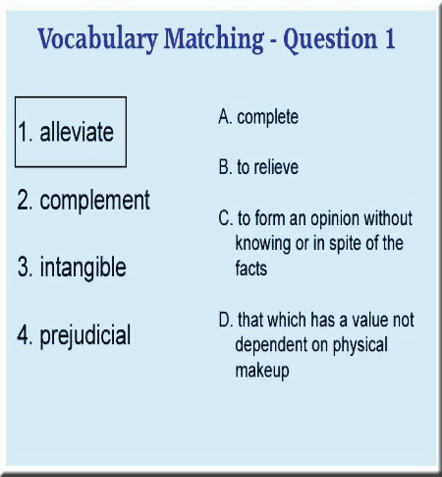
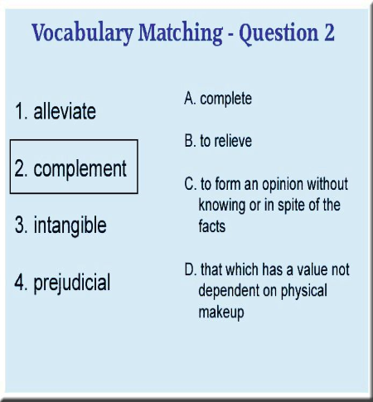

A) A)
B) B)
C) C)
D) D)

113. (U2C6L5:V3) Intangible 114. (U2C6L5:V4) Prejudicial

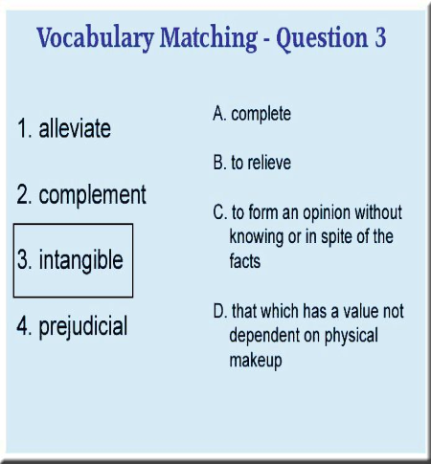
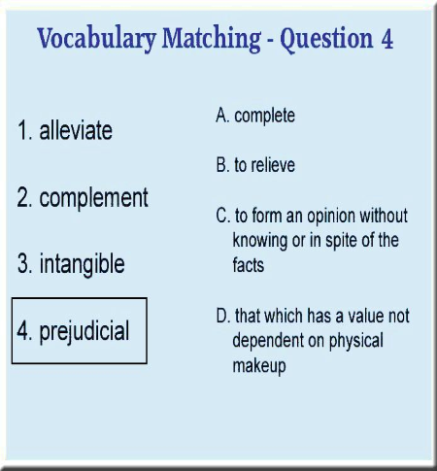
A) A)
B) B)
C) C)
D) D)

Setting Financial Goals

115. (U3C11L1:Q1) Read the following paragraph and select the best option (A-D).

Personal Financial Planning is a process of defining goals, developing a plan to achieve the goals, and putting the plan into action. Goals should be SMART (specific, measurable, attainable, relevant, and time-bound); plans should be rigid; and putting the plan into action requires restraint and responsibility.

A) Replace "achieve" with "prioritize"
B) Replace "rigid" with "flexible"
C) Replace "measurable" with "mistake-free"
D) Replace "restraint" with "restrictions"

116. (U3C11L1:Q2) Preston saved his money for three years so that he could buy a car on his 16th birthday. His dad told him, "If you buy the car, then I'll pay the insurance." However, Preston's dad lost his job a month before Preston's birthday, and told him that he couldn't pay for insurance until he got another job. Preston was really mad at his father because he had saved up for three years and now couldn't buy a car.

What should you tell Preston about financial planning to help him understand his father's position?

A) "You should realize that your goal was unrealistic."
B) "You should realize that your plan was too ambitious."
C) "You should realize that your plan is not your father's plan."
D) "You should realize that your wants are secondary to your dad's needs right now."

117. (U3C11L1:Q3) Ceretta wanted to buy a new video camera, so she developed her own financial planning process to achieve that goal. She showed it to you, to see if you would recommend any changes. You told her that the steps were good, but that you would rearrange the order.

How would you recommend she order her steps?

1. Create a Plan
2. Analyze Information
3. Set Goals
4. Monitor and/or Modify the Plan
5. Implement the Plan

A) 1,3,2,4,5
B) 2,3,1,5,4
C) 3,2,1,5,4
D) 3,1,2,4,5

118. (U3C11L1:Q4) Rondell made a goal to buy the CD collections of his five favorite musical artists. He wrote his goal on paper, and constructed a plan to reach his goal.

Of the following steps in his goal and financial plan, which one would you recommend he change in order to best stay on track?

A) "I will use all of my earnings from my job until I reach my goal."
B) "I will buy one CD per artist at a time."
C) "I will need $80 for each collection."
D) "I want to reach my goal in eight weeks."

119. (U3C11L1:G1) A blueprint for handling all aspects of your money, such as spending, saving, investing, and establishing credit, is called _____________.

A) a budget
B) personal financial planning
C) an allowance
D) a credit card

120. (U3C11L1:G2) Explain the difference between "needs" and "wants" in financial planning.

A) "Needs" are non-essentials like music CDs, while "wants" are essentials like food, shelter, and clothing.
B) There is no difference between "needs" and "wants."
C) "Needs" are essentials like food, shelter, and clothing, while "wants" are non-essentials such as movies and eating out.
D) "Needs" are things you want, while "wants" are things your parents think you should save up for.

121. (U3C11L1:G3) What does the acronym "SMART" stand for in setting financial goals?

A) Specific, Measurable, Attainable, Relevant, Time-bound
B) Simple, Maintainable, Attainable, Responsible, and Timely
C) Smart, Manageable, Attractive, Relevant, and Time-bound
D) Single, Money, Approach, Restraint, Thorough

122. (U3C11L1:G4) Define "cash flow."

A) The speed with which an employer makes an automatic deposit
B) The same thing as interest earned, as in a savings account
C) The measure of the money you receive and the money you spend
D) A difference between the amount of money you are being paid and the amount you save

123. (U3C11L1:V1) What is the definition of the word "goal"?
A) To postpone satisfaction until a later time
B) To desire greatly; wish for
C) Specific, measurable, attainable, relevant, and time-bound goals
D) An aim or purpose; an end to which effort is directed
124. (U3C11L1:V2) What is the definition of the word "wants"?

A) To postpone satisfaction until a later time
B) To desire greatly; wish for
C) Specific, measurable, attainable, relevant, and time-bound goals
D) A principle, standard, or quality considered worthwhile or desirable

125. (U3C11L1:V3) What is the definition of the term "SMART goals"?

A) A condition requiring supply or relief; to be in need or want
B) A principle, standard, or quality considered worthwhile or desirable
C) Specific, measurable, attainable, relevant, and time-bound goals
D) An aim or purpose; an end to which effort is directed

126. (U3C11L1:V4) What is the definition of the word "needs"?

A) A condition requiring supply or relief; to be in need or want
B) To desire greatly; wish for
C) Specific, measurable, attainable, relevant, and time-bound goals
D) An aim or purpose; an end to which effort is directed

127. (U3C11L1:V5) What is the definition of the word "values"?

A) To postpone satisfaction until a later time
B) To desire greatly; wish for
C) Specific, measurable, attainable, relevant, and time-bound goals
D) A principle, standard, or quality considered worthwhile or desirable

128. (U3C11L1:V6) What is the definition of the term "delayed gratification"?

A) To postpone satisfaction until a later time
B) To desire greatly; wish for
C) Specific, measurable, attainable, relevant, and time-bound goals
D) An aim or purpose; an end to which effort is directed

Good Debt Bad Debt

129. (U3C11L5:Q1) You just received your first credit card, so you bought a stereo for $400. Your credit card has an interest rate of 15%, and you decide to make $80 payments each month.

How many months will it take you to pay off?
A) 5 months
B) 6 months
C) 7 months
D) 8 months

130. (U3C11L5:Q2) You just used your new credit card to purchase a big screen TV. The TV cost $2,300. The APR on your credit card is 19%.

If you pay off the credit card in 12 months, how much will you actually pay for your big screen TV?
A) $2319
B) $2528
C) $2649
D) $2737

131. (U3C11L5:Q3) You have $11,000 in debts. You earn enough money to make your payments, but you forget to pay your bills on time so you pay extra bank charges. The company you work for just awarded you a $4,500 bonus, and you want to use it to pay off some debt.

What should you do to best help yourself get out of debt at the earliest possible time?

Debt/Loan: Balance: Interest Rate:
Student Loan $4,500 6%
Bank Credit Card $3,000 15%
Car Loan $2500 5%
Gas Credit Card $1500 10%
Bank Loan $500 8%

A) Pay off the three smallest debts so you only have to remember to make two payments per month
B) Pay off the Student Loan
C) Pay off the Bank Credit Card, the Bank Loan, and Gas Credit Card
D) Pay off the Bank Credit Card and pay $1500 to the Student Loan

132. (U3C11L5:Q4) You want to take a class offered by a private college, but you don't have the $1,500 to pay for it. Since you understand how credit now works, you apply for loans at two banks, a savings and loan, and a credit union.

If you earn enough money to make the necessary payments on any of the loans, which one will cost you the least total amount of money?
A) The First Bank: 9% interest (APR) for 12 months
B) The Second Bank: 9% interest (APR) for 18 months
C) The Savings and Loan: 8% interest (APR) for 24 months
D) The Credit Union: 7% interest (APR) for 36 months

133. (U3C11L5:G1) According to NEFE, ________ means someone is willing to loan you money - called principal - in exchange for your promise to pay it back, usually with interest.

A) mutual funds
B) usury
C) credit
D) debit

134. (U3C11L5:G2) According to NEFE, what is an "A.P.R."?

A) Approved Percentage Rate
B) Annual Percentage Rate, or the amount it costs you per year to use credit, expressed as a percentage rate
C) Annual Percentage Return (or investment)
D) Annual Performance Rate
135. (U3C11L5:G3) Name four benefits to credit cards, according to the NEFE program.

A) Access to cash in an emergency; the ability to use the purchased product (such as a car) now; safety and convenience; to earn bonus points or miles
B) Inexpensive to use; the ability to use the purchased product (such as a car) now; safety and convenience; to earn bonus points or miles
C) Make budgeting easier; the ability to use the purchased product (such as a car) now; safety and convenience; to earn bonus points or miles
D) Help you establish a line of credit; the ability to use the purchased product (such as a car) now; safety and convenience; to earn bonus points or miles

136. (U3C11L5:G5) According to the NEFE program, how much of your net income or take-home pay should go toward all your loan payments, excluding mortgage?

A) A maximum of 20%
B) A maximum of 10%
C) A maximum of 25%
D) No more than 30%

137. (U3C11L5:G7) According to the NEFE program, what is the first step towards ensuring a successful career that leads to financial stability?

A) Having a high school diploma or college degree
B) Using personal connections to secure a well-paying job
C) Saving 10% of your allowance as a child to pay for college
D) Learning a foreign language to be employable in the future

138. (U3C11L5:G8) According to NEFE, ______________ is the entire amount of money you owe to lenders.
A) capital
B) credit
C) collateral
D) debt

139. (U3C11L5:V1) Choose the term that best completes the sentence below.

__________ is a trust or promise to pay later for goods or services purchased today.
A) Annual fee
B) Credit history
C) Debt
D) Credit

140. (U3C11L5:V2) Choose the term that best completes the sentence below.

The cost of consumer credit expressed as a dollar amount including interest and service fees is known as ___________.
A) annual percentage rate (APR)
B) finance charge
C) loan term
D) grace period

141. (U3C11L5:V3) Choose the term that best completes the sentence below.

The agreed length of a loan is a/an __________.
A) loan term
B) credit report
C) interest
D) credit history

142. (U3C11L5:V4) Choose the term that best completes the sentence below.

___________ is a liability or obligation in the form of bonds, loan notes, or mortgages owed to another person.
A) Annual fee
B) Finance charge
C) Debt
D) Bankruptcy

143. (U3C11L5:V5) Choose the term that best completes the sentence below.

A yearly fee charged by credit grantors for the privilege of using a credit card is known as a/an ___________.
A) annual fee
B) loan term
C) credit
D) grace period

144. (U3C11L5:V6) Choose the term that best completes the sentence below.

___________ is when one becomes financially ruined.
A) Interest
B) Annual percentage rate (APR)
C) Credit report
D) Bankruptcy
145. (U3C11L5:V7) Choose the term that best completes the sentence below.

A record of how one has paid credit accounts in the past is known as a ___________.

A) credit report
B) credit history
C) credit
D) debt

146. (U3C11L5:V8) Choose the term that best completes the sentence below.

____________ is the cost of credit at a yearly rate.

A) Annual percentage rate (APR)
B) Annual fee
C) Interest
D) Bankruptcy

147. (U3C11L5:V9) Choose the term that best completes the sentence below.

The ________ is a time frame in which a person can avoid finance charges by paying off a balance in full before its due date.

A) loan term
B) finance charge
C) grace period
D) debt

148. (U3C11L5:V10) Choose the term that best completes the sentence below.

A/an _____________ is a record or file to a prospective lender or employer on the credit standing of a prospective borrower.

A) credit report
B) grace period
C) credit
D) annual fee
149. (U3C11L5:V11) Choose the term that best completes the sentence below.

The cost of borrowing or lending money that is usually a percentage of the amount borrowed or loaned is known as ___________.

A) debt
B) credit
C) finance charge
D) interest

Insurance Protection What You Have

150. (U3C11L6:Q2) John is a new construction worker. Like most new construction workers, he gets assigned the most menial and dangerous jobs, and he gets injured frequently. He hasn't been injured seriously, but he thinks it's time he got some health insurance, "just in case."

When he asks you what features he should have in his health insurance plan, which one of the following would you tell him not to include in the plan?

A) High deductibles
B) Low premiums
C) Group policies
D) Disability Insurance

151. (U3C11L6:Q4) While driving to the store, you swerved to miss a dog and drove into a tree. You, the dog, and the tree are alright, but it's obvious that it will cost several thousand dollars to fix your new car. You have insurance, but you didn't really read your policy.

When you pull out your policy, what type of coverage are you hoping to see on it?

A) Liability coverage
B) Uninsured motorist
C) Underinsured motorist
D) Collision

152. (U3C11L6:G1) According to NEFE, ___________ means that you use various ways to deal with potential personal or financial loss.

A) prior planning
B) financial planning
C) fiscal management
D) risk management

153. (U3C11L6:G2) ____________ is protection against large-scale financial loss, according to the NEFE program.

A) Credit
B) Betting
C) Deductible
D) Insurance

154. (U3C11L6:G3) According to NEFE, what is a "deductible"?

A) Any amount you withdraw from your checking account
B) The amount of the loss you must pay out of your own pocket before an insurance company begins to reimburse you for a large loss
C) What an insurance company will pay you for a large loss
D) The replacement value of an item such as a home or car

155. (U3C11L6:G4) T or F: According to the NEFE program, any time someone else is dependent on your income to help pay their bills, you need life insurance coverage.

A) True
B) False
156. (U3C11L6:V1) It's the Question Game!
Compensation for specific potential future losses in exchange for a periodic payment

A) What is a deductible?
B) What is insurance?
C) What is an insurance premium?
D) What is risk management?

157. (U3C11L6:V2) It's the Question Game!
The process of analyzing exposure to risk and determining how to best handle such exposure

A) What is a deductible?
B) What is insurance?
C) What is an insurance premium?
D) What is risk management?

158. (U3C11L6:V3) It's the Question Game!
The periodic payment made on an insurance policy

A) What is a deductible?
B) What is insurance?
C) What is an insurance premium?
D) What is risk management?
159. (U3C11L6:V4) It's the Question Game!
The amount of a loss that an insurance policy holder has to pay out-of-pocket before reimbursement begins

A) What is a deductible?
B) What is insurance?
C) What is an insurance premium?
D) What is risk management?

160. (U3C12L5:Q1) John is teaching a lesson on using a rifle. He would like to include a graphic organizer or Thinking Map® to help students learn the parts of a rifle.

Which of the following options (A-D) would be the most appropriate for this lesson?

A) Flow Chart
B) Bridge Map
C) Concept Web
D) Brace Map

Thinking Maps and Graphic Organizers

161. (U3C12L5:Q2) Read the following sentence and decide which option (A-D) is most correct.

"When using Thinking Maps®, it is very important to match the Thinking Map® to the thinking process that you want students to use in completing the activity."

A) True: Thinking Maps® allow students to select a thinking process to complete an activity.
B) True: Thinking Maps® are directly tied to particular thinking processes, and establish a "common language" for illustrating each thinking process.
C) False: Thinking Maps® are used to illustrate communication styles, not thinking processes.
D) False: Thinking Maps® can easily be adapted to address a variety of thinking processes.

162. (U3C12L5:Q3) Select the option (A-D) which describes the most effective way to use graphic organizers to enhance learning.

A) The teacher creates a graphic organizer prior to class and shares it with the students during class to illustrate a point.
B) Students create a graphic organizer as part of the learning process to illustrate the relationship of the concepts and ideas being learned.
C) Students study a graphic organizer provided in a handout and discuss it with a partner.
D) The teacher creates a graphic organizer at the end of the class period to summarize the main points of the lesson.
163. (U3C12L5:Q4) Read the paragraph below and determine which of the options (A-D) is most correct.

"Logan is preparing a lesson on the writing of the Constitution. Students will follow the progress of the
Continental Congress as they met
to write the Constitution and work through the various issues and
challenges that arose. As part of the final report, students will create a
Concept Web to illustrate the sequence of events in the writing of the Constitution."

A) Replace "Concept Web" with "Brace Map"
B) Replace "Concept Web" with "Double Bubble Map"
C) Replace "Concept Web" with "Bridge Map"
D) Replace "Concept Web" with "Flow Map"

164. (U3C12L5:G1) What is a graphic organizer and what is its use?
A) A notebook for organizing one's work in math class using grid paper.
B) A tool for learning the structure of thinking skills using visual pictures.
C) A tool for recording emotions to improve one's emotional intelligence level.
D) A tool for recording marching drills and maneuvers using diagrams.

165. (U3C12L5:G2) What kind of graphic organizer is best used for comparing and contrasting topics?
A) A list
B) Lined notebook paper
C) The Venn Diagram
D) Poster board
166. (U3C12L5:V1) What is the definition of the word "classifying"?

A) A process of sorting things into categories or groups
B) A process of identifying the relationship between a whole physical object and its parts
C) A process of seeing the relating factor or the same relationship to something
D) A process of ordering or examining states of an event

167. (U3C12L5:V2) What is the definition of the word "analogies"?

A) A process of identifying the interrelationship of what results from an action
B) A process of identifying the relationship between a whole physical object and its parts
C) A process of seeing the relating factor or the same relationship to something
D) A process of ordering or examining states of an event

168. (U3C12L5:V3) What is the definition of the term "part-whole relationships"?

A) A process of sorting things into categories or groups
B) A process of identifying the relationship between a whole physical object and its parts
C) A process of seeing the relating factor or the same relationship to something
D) A process of ordering or examining states of an event

169. (U3C12L5:V4) What is the definition of the word "sequencing"?

A) A process of sorting things into categories or groups
B) A process of identifying the interrelationship of what results from an action
C) A process of seeing the relating factor or the same relationship to something
D) A process of ordering or examining states of an event

170. (U3C12L5:V5) What is the definition of the term "thinking process"?

A) The organized way in which thinking occurs
B) A process of seeing qualities, characteristics, traits, and/or properties or things
C) A process where a specific concept is defined and explored
D) A process of identifying similarities and differences of things
171. (U3C12L5:V6) What is the definition of the term "comparing and contrasting"?

A) A process of identifying the relationship between a whole physical object and its parts
B) A process of seeing qualities, characteristics, traits, and/or properties or things
C) A process where a specific concept is defined and explored
D) A process of identifying similarities and differences of things

172. (U3C12L5:V7) What is the definition of the word "describing"?

A) A process of identifying the interrelationship of what results from an action
B) A process of seeing qualities, characteristics, traits, and/or properties or things
C) A process where a specific concept is defined and explored
D) A process of identifying the relationship between a whole physical object and its parts

173. (U3C12L5:V8) What is the definition of the term "defining in context"?

A) The organized way in which thinking occurs
B) A process of identifying the relationship between a whole physical object and its parts
C) A process where a specific concept is defined and explored
D) A process of identifying similarities and differences of things

174. (U3C12L5:V9) What is the definition of the term "cause and effect"?

A) The organized way in which thinking occurs
B) A process of identifying the relationship between a whole physical object and its parts
C) A process where a specific concept is defined and explored
D) A process of identifying the interrelationship of what results from an action

