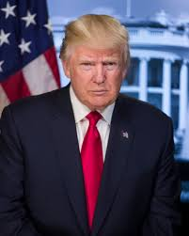
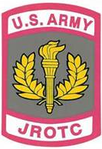
Cadet Command Chain Of Command

Commander-in-Chief
Honorable Donald John Trump
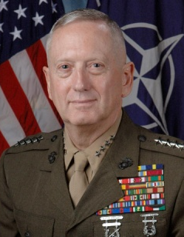
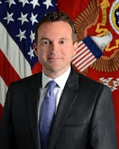
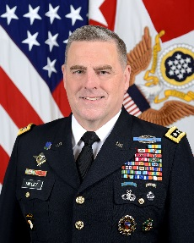
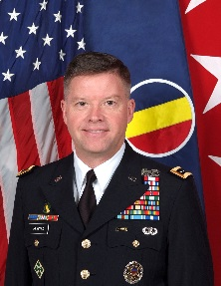

Secretary of Defense Secretary of The Army United States Army Commanding General
Honorable James N. Mattis Honorable Eric K. Fanning Chief of Staff U.S. Army Training and
General Mark. A Milley Doctrine Command
General David G. Perkins
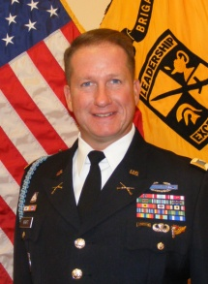
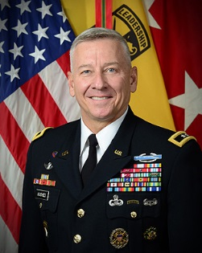
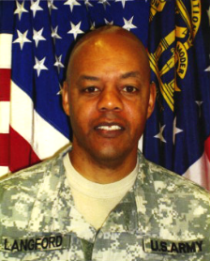
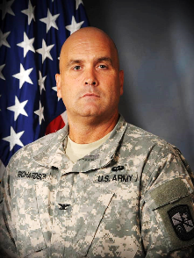

Commanding General U.S. Director, U.S. Army JROTC Commander Sixth Brigade Senior Army Instructor
Army Cadet Command Colonel William Richardson Colonel Nelson G. Kraft Lieutenant Colonel
Major General Christopher P. Hughes Darryl Langford

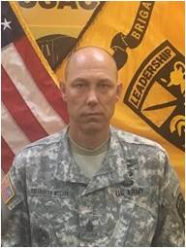
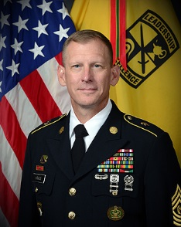
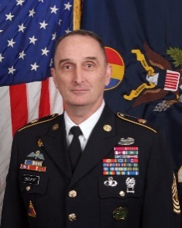
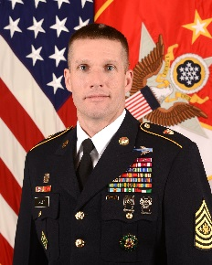

Sergeant Major of the Army CSM U.S. Training and CSM U.S. Cadet Command CSM Sixth Brigade
SMA Daniel A. Dailey Doctrine Command CSM Kenneth J. Kraus JR. CSM Michael C. McCann
CSM David S. Davenport

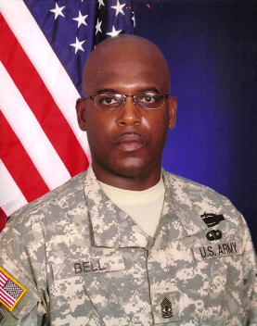

Army Instructor First Sergeant Anthony Bell Sr.

